
Tafila Technical University
Faculty of ITC/Information Technology Department
Data Mining Assignment #1 Due date: 02/08/2025
Student Name | انس صالح إبراهيم العطيوى | Student ID | 320230601061
Instructor Name | Dr. khalid Alemerien | Section No.

SLO: 2 | Grade: /7

Problem Description: Use the “Brain Stroke” dataset, which is hosted on Kaggle
https://www.kaggle.com/datasets/jillanisofttech/brain-stroke-dataset
Then, write a Python code to do the following tasks:
- Download the dataset on your computer
- Upload the dataset on Python for analysis (Python code)

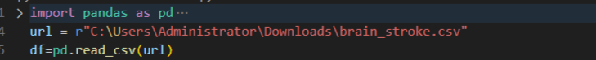

- Provide a description (Number of instances, features, datatypes, statistical summary) of the dataset (Python code + Output)



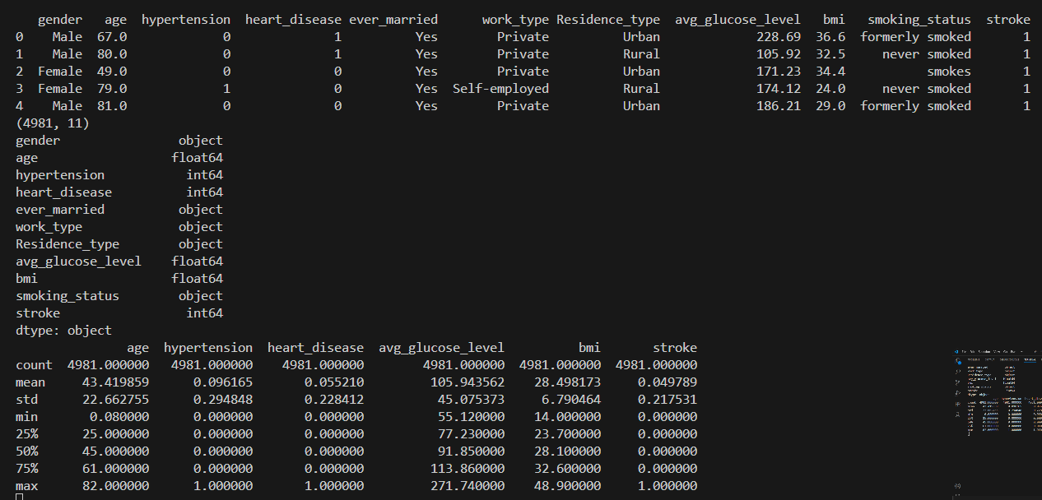
- Draw the following figures:
  - Pair Plot for all numeric features. (Python code + Output + Short description)
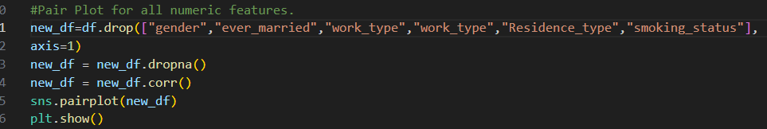
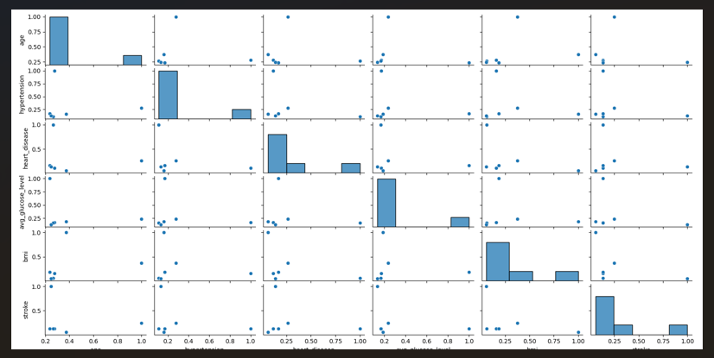
* Note that increasing age increases the probability of contracting all diseases, and the relationship between them is direct
  - Count Plot for the “smoking_status” feature.
(Python code + Output + Short description)

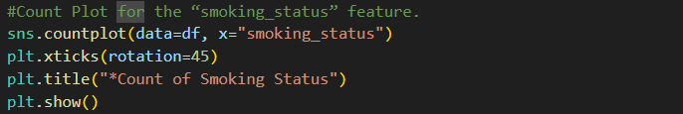
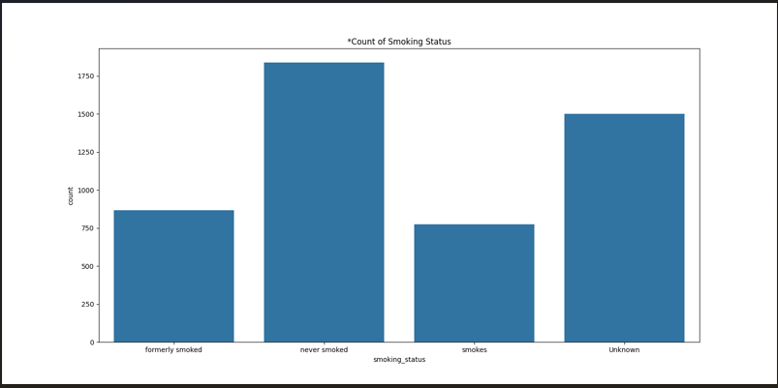
*Note that most of them are non-smokers and the Unknown group is a high percentage, which leads to confusion in the drawing.

  - Point Plot for the “avg_glucose_level” by gender and work_type features.
(Python code + Output + Short description)

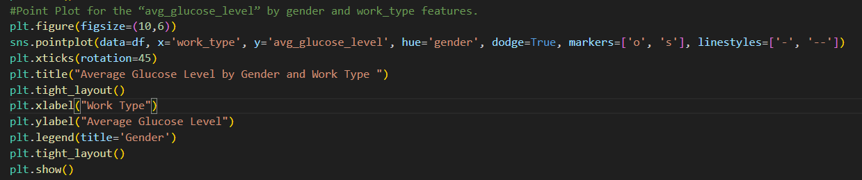
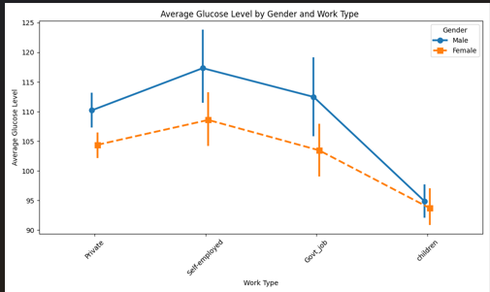
*noticed that the average glucose level in men is higher than in women. I"" also noticed that people who have private jobs have higher GAL, followed by government jobs,\n and then children.

  - Regression Plot for “bmi” and “age” features.
(Python code + Output + Short description)

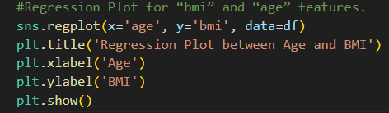
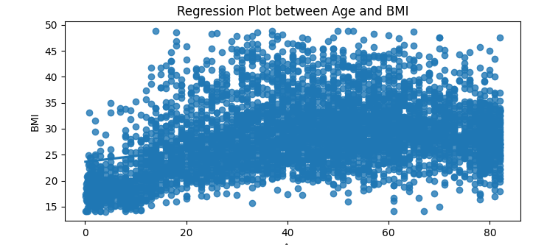
*I noticed that there is a direct relationship between age and BIM.

  - Histogram Plot for “work_type” feature.
(Python code + Output + Short description)
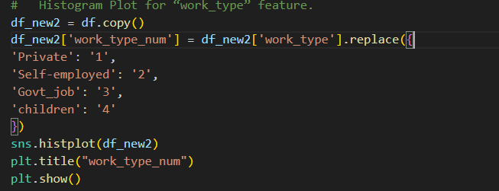
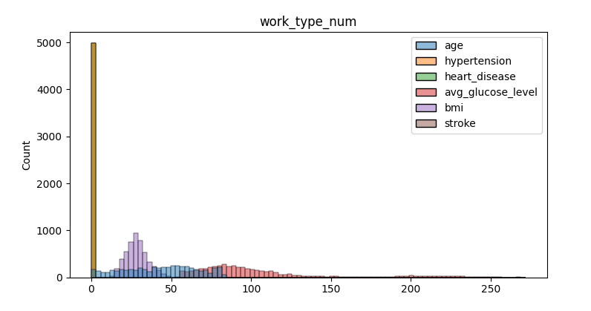
* Most patients did not suffer a heart attack.

Code:
import pandas as pd
import matplotlib.pyplot as plt
import seaborn as sns
url = r"C:\Users\Administrator\Downloads\brain_stroke.csv"
df=pd.read_csv(url)
print(df.head())
print(df.shape)
print(df.dtypes)
print(df.describe())
#Pair Plot for all numeric features.
new_df=df.drop(["gender","ever_married","work_type","work_type","Residence_type","smoking_status"],
axis=1)
new_df = new_df.dropna()
new_df = new_df.corr()
sns.pairplot(new_df)
plt.show()
#Count Plot for the “smoking_status” feature.
sns.countplot(data=df, x="smoking_status")
#plt.xticks(rotation=45)
plt.title("*Count of Smoking Status")
plt.show()
#Point Plot for the “avg_glucose_level” by gender and work_type features.
plt.figure(figsize=(10,6))
sns.pointplot(data=df, x='work_type', y='avg_glucose_level', hue='gender', dodge=True, markers=['o', 's'], linestyles=['-', '--'])
plt.xticks(rotation=45)
plt.title("Average Glucose Level by Gender and Work Type ")
plt.tight_layout()
plt.xlabel("Work Type")
plt.ylabel("Average Glucose Level")
plt.legend(title='Gender')
plt.tight_layout()
plt.show()
#Regression Plot for “bmi” and “age” features.
sns.regplot(x='age', y='bmi', data=df)
plt.title('Regression Plot between Age and BMI')
plt.xlabel('Age')
plt.ylabel('BMI')
plt.show()
# Histogram Plot for “work_type” feature.
df_new2 = df.copy()
df_new2['work_type_num'] = df_new2['work_type'].replace({
'Private': '1',
'Self-employed': '2',
'Govt_job': '3',
'children': '4'
})
sns.histplot(df_new2)
plt.title("work_type_num")
plt.show()

